**Uncovering Insights in Nuclear Dataset Using Exploratory Data Analysis**

**Example Dataset** :“Nuclear Share of Electricity Generation" from Kaggle.  
  
**Objective:**

* Analyze nuclear electricity production data to uncover trends and patterns.
* Identify key factors influencing nuclear electricity generation.
* Provide actionable insights and recommendations for policy and decision-makers.

### **Introduction**

Nuclear energy is a significant source of electricity generation worldwide, offering a low-carbon alternative to fossil fuels. Understanding the trends and patterns in nuclear electricity production is crucial for energy planning and policy formulation. This project aims to perform an exploratory data analysis (EDA) on a dataset containing nuclear electricity statistics for various countries. By analyzing this data, we aim to uncover insights into the global nuclear energy landscape and identify factors that influence nuclear electricity generation.

**Dataset Description**

The dataset contains information on nuclear electricity production for different countries over several years. Key attributes include:

* Country: The name of the country.
* Year: The year of the record.
* Electricity production (TWh): The total nuclear electricity production in terawatt-hours.

**Exploratory Data Analysis:**Load the data  
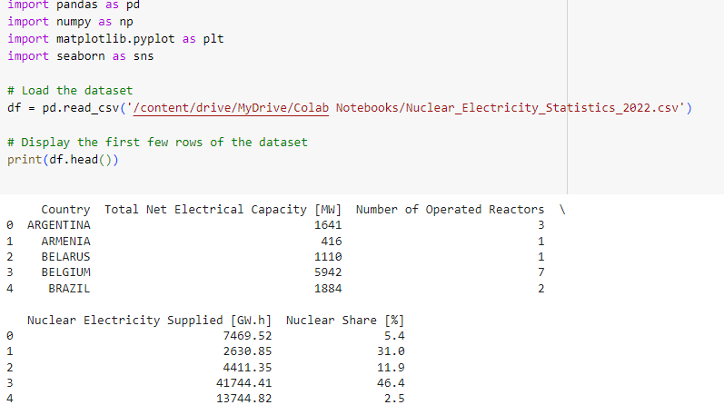

**Data Cleaning :Handle missing values, outliers, and duplicates.**

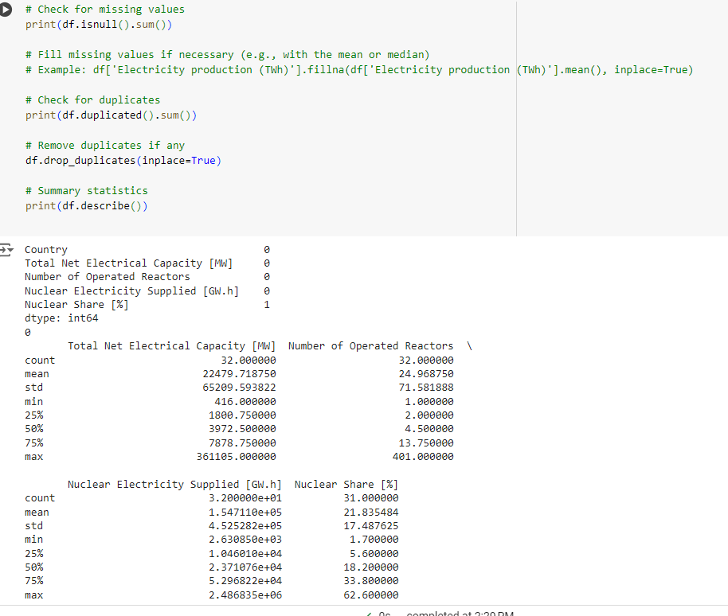

#### **Summary Statistics**

Summarize the dataset to understand its distribution

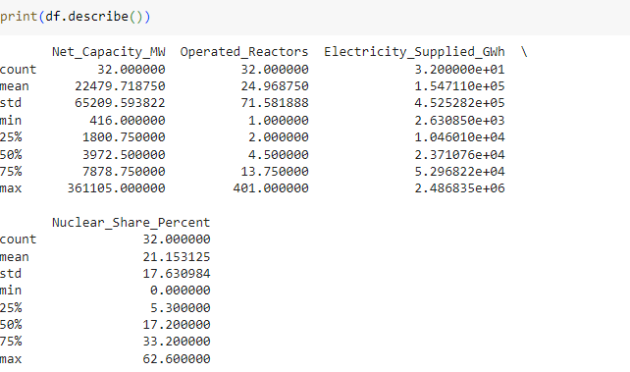

**Data Visualization and Discussion**

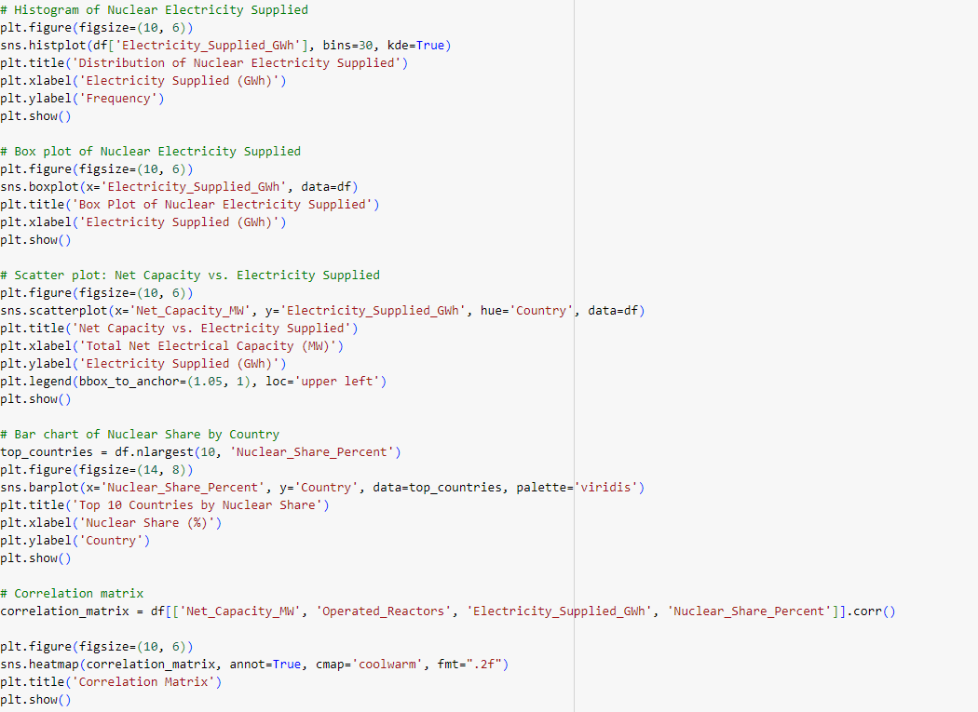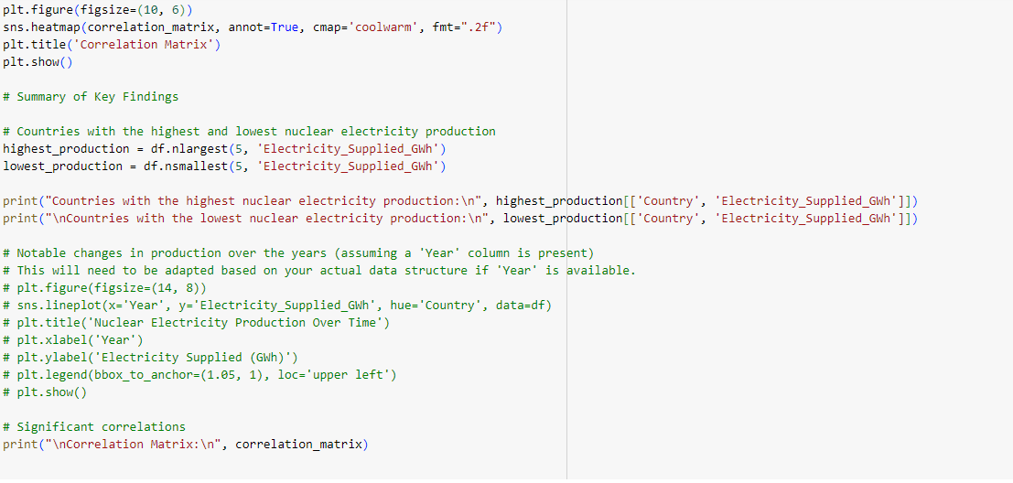

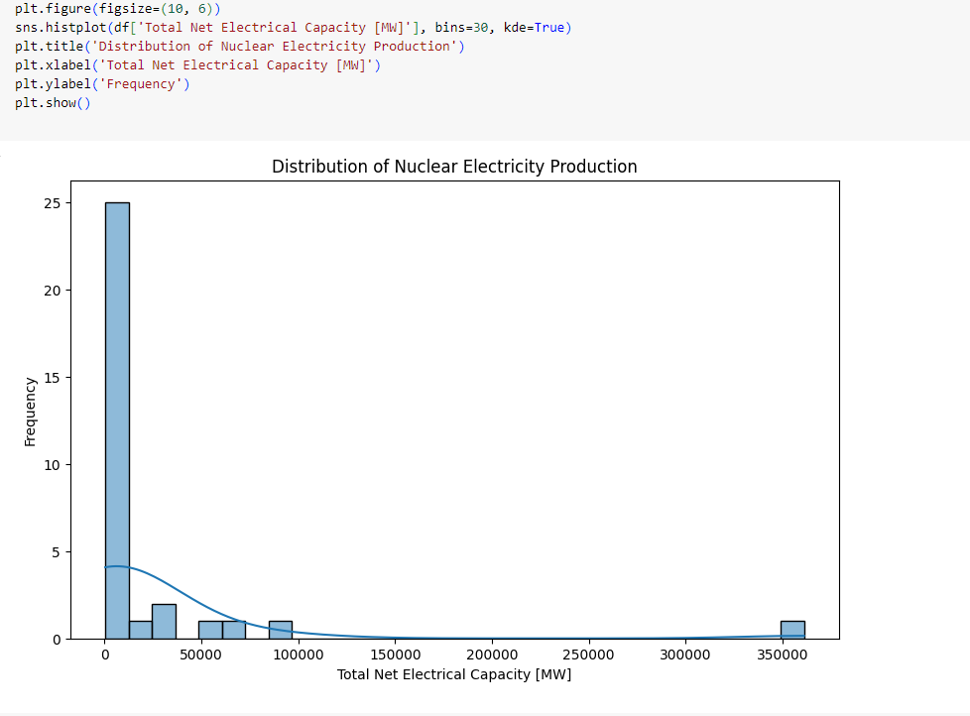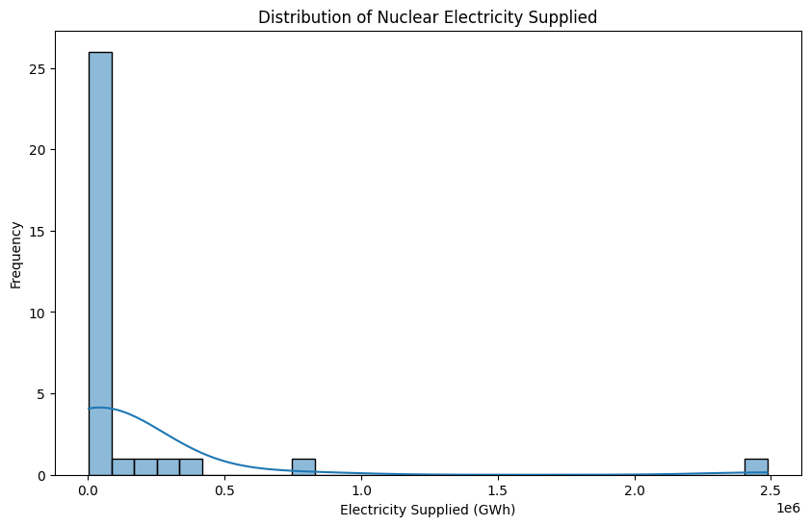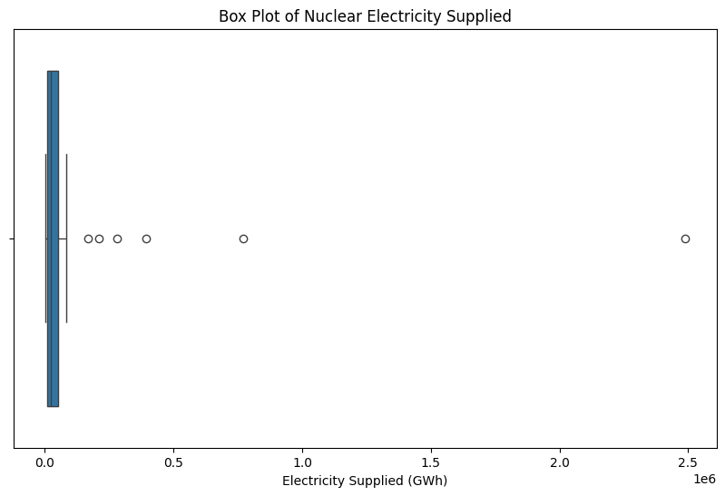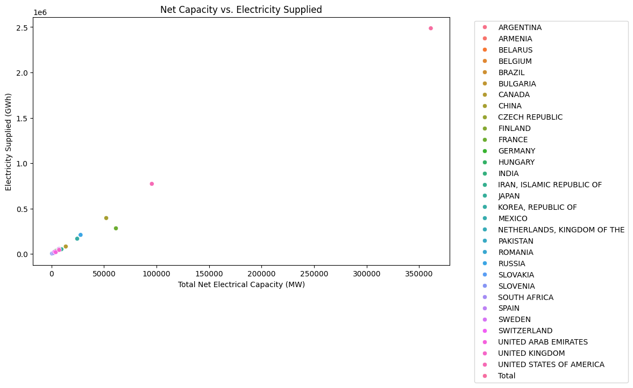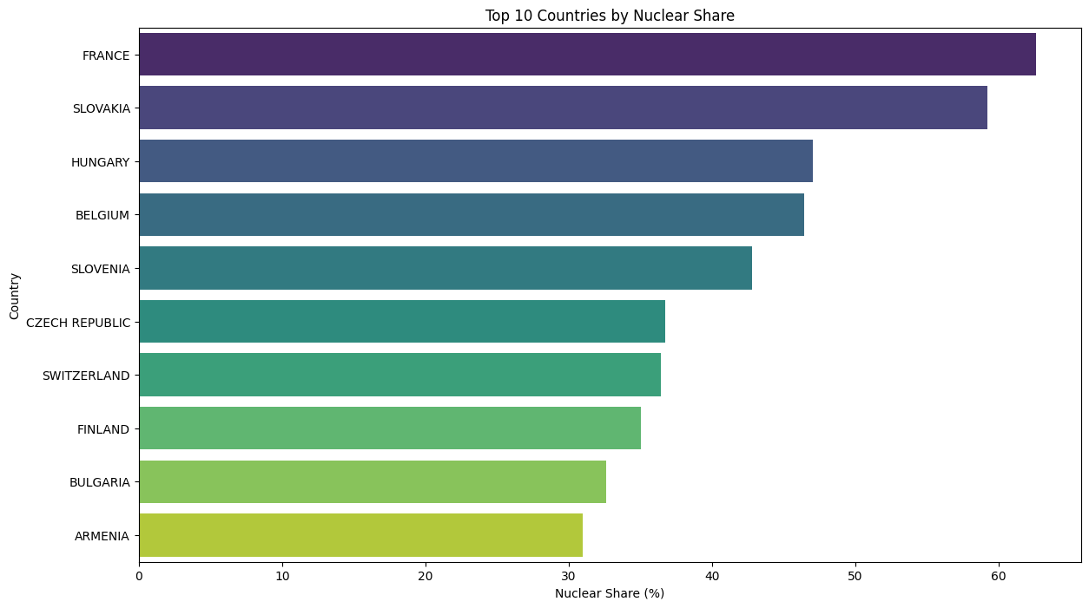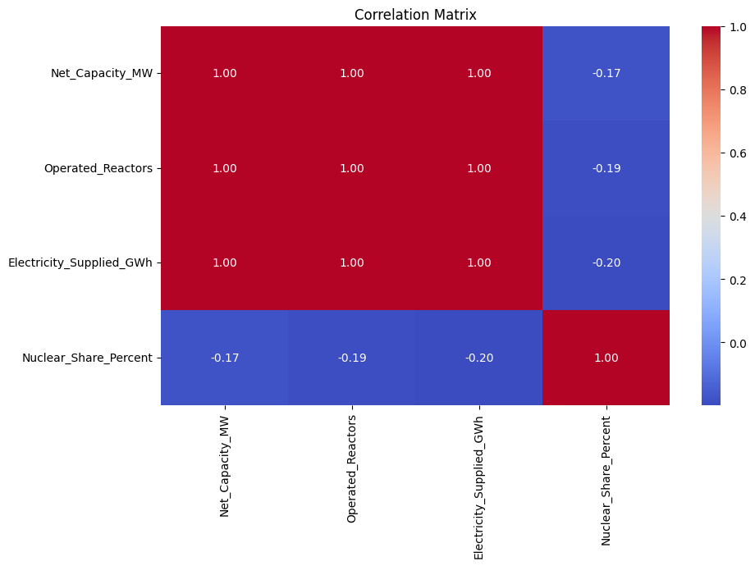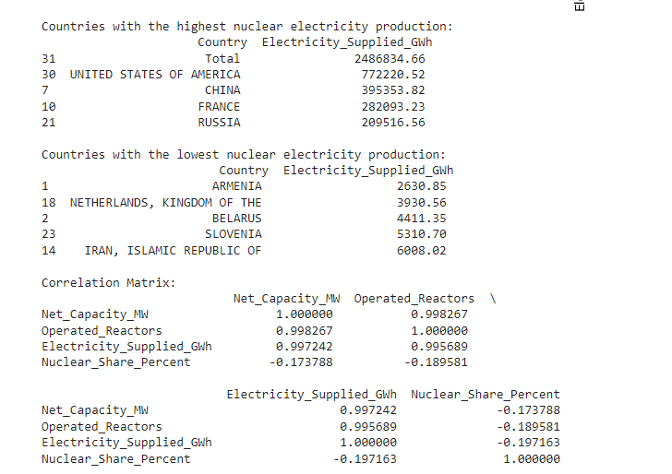

**Summarize key findings:**

* Most of the countries have Total net electric Capacity is less than 50000 Mw.
* United States of America has the most Nuclear Electric Production.
* Armenia has the lowest Nuclear Electric Production.
* There is a strong correlation between Net_Capacity_MW and Electricity_Supplied_GWh, indicating that countries with higher net capacity tend to produce more nuclear electricity.
* The correlation matrix provides insights into how various factors like the number of operated reactors and the nuclear share percentage are related.

### **Conclusion**

* + The exploratory data analysis revealed significant insights into nuclear electricity production across different countries. Countries like the USA and France are leading in nuclear electricity production, while countries like Armenia and Netherlands have much lower production. The strong correlation between net electrical capacity and electricity supplied underscores the importance of infrastructure in nuclear energy generation.

References:https://www.kaggle.com/datasets/kanchana1990/nuclear-share-of-electricity-generation